Boca Raton Campus  
High Stakes Testing  
ACT, IQT, KRYTERION, PAN, PROMETRIC

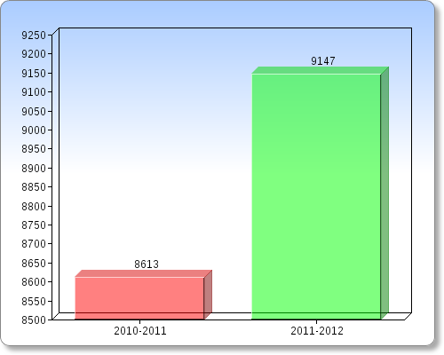

High Stakes Testing

Employer Examinations/Certifications  
ACT, IQT, KRYTERION, PAN, PROMETRIC